First Name:
Last Name:
MI:
City: State: Zip:
Date:

Street Address: Apt #:

DEMOGRAPHIC INFORMATION

Cell #: Texts?: Y/N
Home /Work ? #:

Email:
Gender:  Female  Male
Last Name:
Birthdate:
Job/Daily Tasks?

How did you hear about us? Are you on Facebook? Y or N

EMERGENCY CONTACTS

Emergency Contact: Relationship:

Address: Phone #:

I understand that the services offered through The Body Works! LLC and companies or services associated with them are not a substitute for medical care and that any information provided is for educational purposes only and is not diagnostically prescriptive in nature. I agree to actively participate, as much as possible, in my own healing. I have disclosed all known medical and physical conditions and will provide updates. I understand all policies (cancellation, timeliness) and will adhere to them. I recognize potential risk to the musculoskeletal system (dizziness, discomfort in breathing, heart attack) and hereby certify that I know of no medical problem (except those noted below) that would increase my risk of illness and injury as a result of participation in services offered. No services at The BodyWorks! LLC are sexual and any said remarks or actions will end the service. By signing this consent form, I understand that I am personally responsible for my actions during my tenure with the The Body Works! LLC and that I waive the responsibility The Body Works! LLC if I should incur any injury as a result of my negligence.
First Name:
Client Signature: Date:

MEDICAL HISTORY

Current Physician(s):

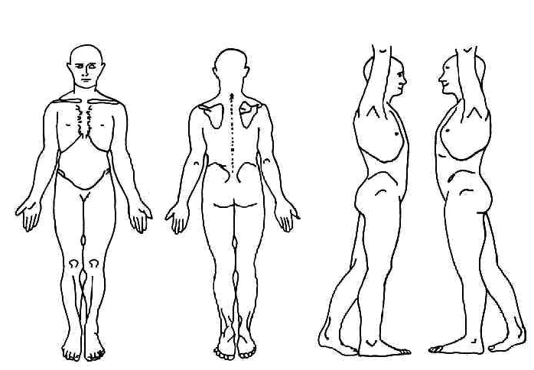
Indicate areas of discomfort below. What activities/movements cause discomfort?

Please check YES or NO. Please explain any Yes
answers!
Y N Any contagious disease
Y N Any recent surgeries
Y N Any recent injuries
Y N Arthritis
Y N Cancer
Y N Diabetes
Y N Headaches
Y N Heart Problems
Y N Hematoma, Bruise
Y N High Blood Pressure
Y N Lymphedema, Swelling
Y N Pregnancy. High Risk? Y/N
Y N Other Medical Condition

